**Abstract Reasoning Experiment - Procedure**

**General Preparation**

1. Instructions to participants:
   * Before the day of the expriment:
     1. No hair product
     2. No eye makeup
     3. If corrected-vision, wear contact lenses instead of glasses if possible
   * Try to refrain from moving, clenching their jaw, and blinking as much as possible
   * During breaks, take as long as needed but try to keep head still and not move too much
2. Measure screen to chin-rest distance
3. Check tape marks on location of screen and EyeLink camera
4. Check screen resolution and refresh rate
5. File naming:
   * Pattern: “cp<participant ID><session number>”
   * using two digits (leading zero) for both Participant ID and Session number
   * e.g., participant 1, session 1: “cp0101”

**First Steps**

1. If it is the participant’s first session:
   1. Informed consent form
2. Turn on all three experimenter’s PCs and the participant’s PC
3. Turn on light, decrease brightness to minimum. Make sure the neons are not flickering, otherwise try to increase the brightness a bit until they stop.
4. Plug in the Eye tracker
5. connect the battery to the EEG amplifier and turn it on
6. turn off the speakers
7. Ask participant to put phone / electronic devices away
8. Log in to the **FMG-research server** (see guide at the end)
   1. Navigate to ' **Projects/2024_Pinier_FMG-7163_reasoning_EEG/data/Lab'**
9. **EEG computer:**
   1. Launch ActiView
   2. Check the battery level, swap the battery if needed
   3. Select configuration file:
      1. Click on "About / configure" tab
      2. Click on “Load CFG File”
   4. Select "Michael2.cfg"
   5. Press start on upper left corner
10. **EyeLink computer:**
    1. click on "Tracker"
    2. Load the correct configuration:
       1. Click on “**Set options**” -> “**Select Config…**”
       2. Select the **first** **config**: “Desktop | Stabilized Head | Monocular | 35mm lens”
       3. Then, click on “**Load Defaults**”
       4. Click on “**DIAMETER**” next to “Pupil Size Data”
       5. Click on “**Button Flags**” under “File Sample Contents”
       6. Make sure the settings match the ones below:

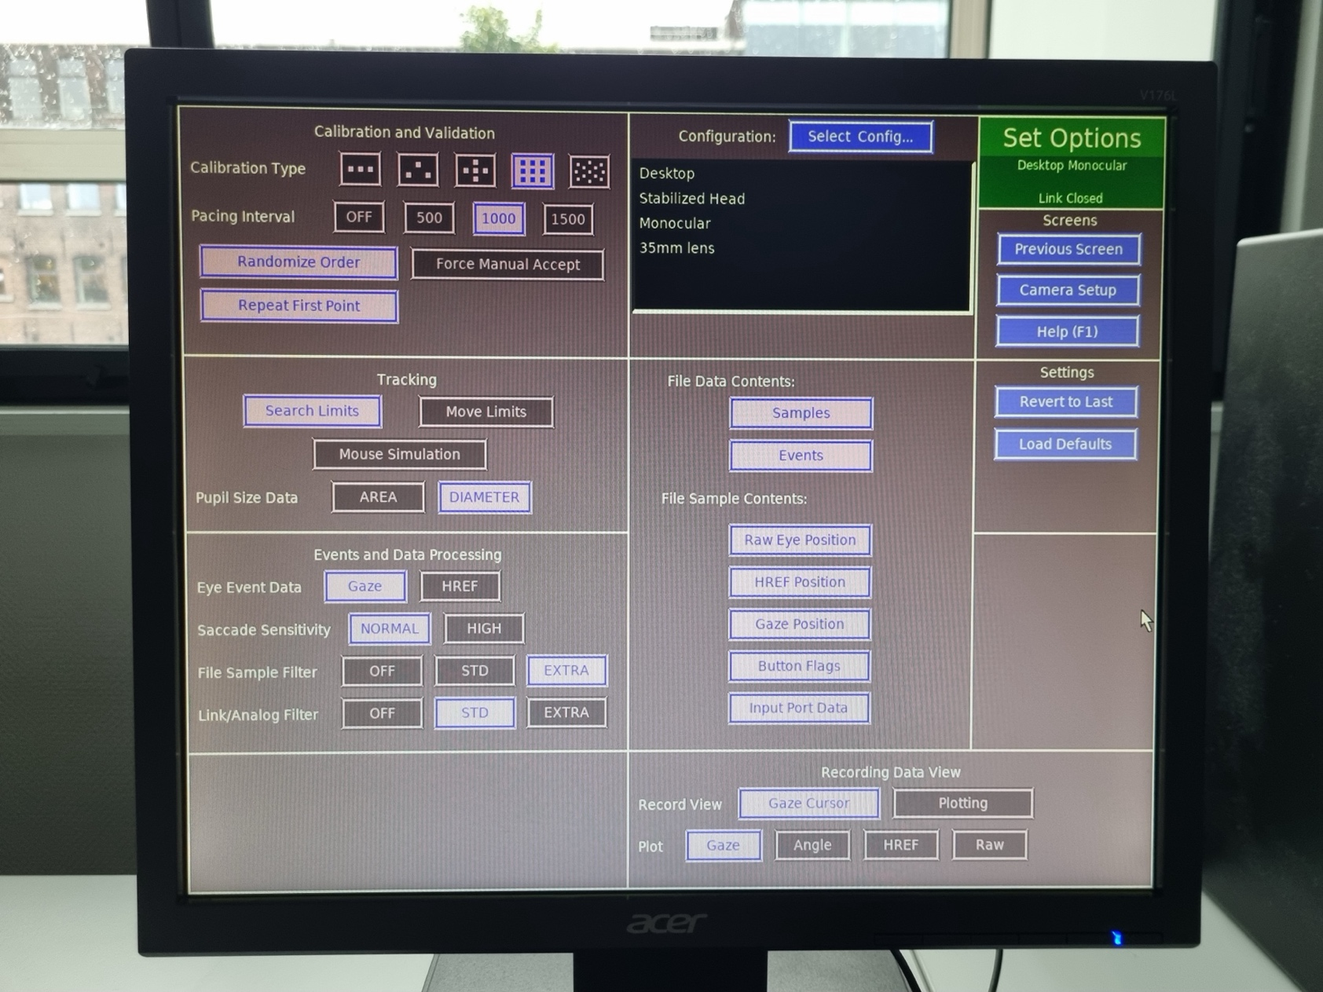

**Setting up EEG – Part 1**

1. Measure the head’s circumference and select the right cap size

|  |  |  |
| --- | --- | --- |
| Small / Medium | 52-56 cm | Yellow & Red |
| Medium | 54-58 cm | Red |
| Medium / Large | 56-60 cm | Blue & Red |
| Large | 58-62 cm | Blue |

1. Fit the cap on the head, get ears out if more comfortable for participant
2. Make sure the cap is aligned:

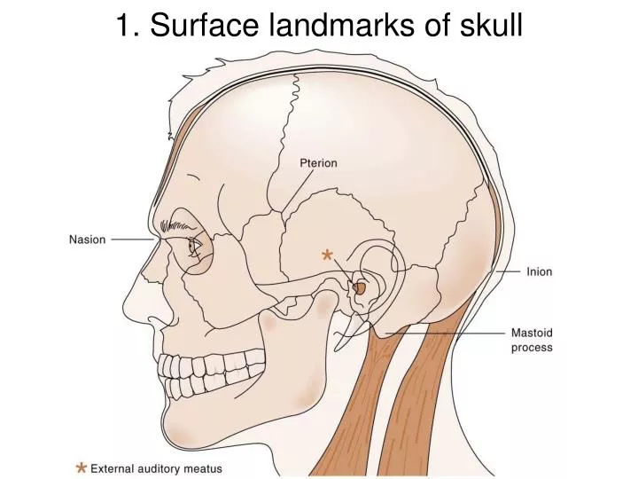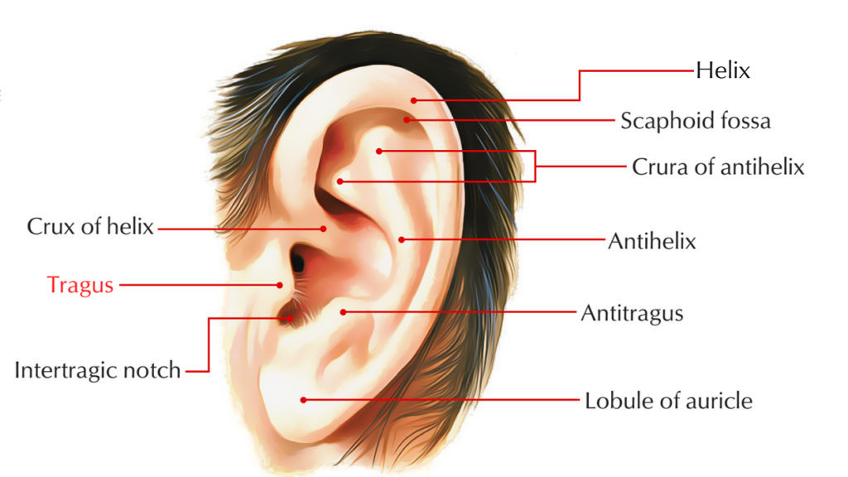

* + Measure the distance between the inion and nasion, Cz should be at the midpoint
  + Measure the distance between the tragi (protrusion on front of the ear), Cz should be at the midpoint

1. Fasten the cap’s strap and ensure it is relatively tight
2. Apply conductive gel to EEG cap
   * Fill a clean syringe with conductive gel
   * Gently part the hair beneath each electrode’s hole by slowly rotating the tip of the syringe on the scalp
   * Slowly inject a small amount of gel while gradually withdrawing the syringe
3. Place the eye electrodes

1. Check the electrodes activity on the monitor and readjust the cap / gel if necessary
   * Note any problematic electrodes or unusual circumstances in a “notes.txt” file in the session’s folder

**Setting up Eye-tracking – Part 1**

1. Launch the experiment’s script:
   1. open the command line and cd to the experiment’s folder: C:\Users\topuser\Documents\ChrisPinier\abstract_reasoning\experiment-Lab
   2. run “**poetry run python experiment.py**”
2. Perform dominant eye test

Instructions:

* + 1. **Find a target**: Select a small object or mark in the distance, such as a light switch or a picture on the wall.
    2. **Make a circle**: With one hand, form a circle by touching the tip of your thumb and index finger together, leaving a small gap through which you can look.
    3. **Hold your hand out**: Extend your arm fully in front of you and center the target within the circle, while keeping both eyes open.
    4. **Focus on the target**: Look at the target through the circle you made with your hand.
    5. **Close one eye**: Without moving your head or hand, close one eye.
    6. **Close the other eye**: Now close the other eye.

Results:

* + - If the target stays within the circle when you close one eye but moves or disappears when you close the other, the eye that keeps the target in view is your dominant eye.
    - If the target shifts out of the circle when one eye is closed, the other eye is your dominant eye.

1. Fill out the dialogue box:

1. Set up chin-rest: have the participant place the chin rest at a position that is comfortable to them
2. Measure eye to screen distance
   1. Ask the participant to take one end of the tape and place it below their dominant eye
   2. Make a straight line to the screen
   3. **record the distance** **in millimeters** it in the dialogue box
3. On the participant’s computer, click on the pupil of the dominant eye using the mouse
4. Adjust the camera focus

**Setting up the EEG – Part 2**

1. In ActiView, Click on "**Start File**".
2. Fill out the fields (copy filename), ignore Error 7003 -> click on “**continue**”
3. Navigate to the data folder**: C:\Data\ChrisPinier\abstract-reasoning**
4. Enter the **filename** using the pattern described in the “**General Preparation**” section
5. Click on “**Paused**” to start saving data, the button above will turn green and show “Saving”

**Launching the Experiment**

1. **Press A** multiple times to use the **auto-threshold** until you get stable CR values
2. **Press C** for **calibration**, move mouse cursor away, press enter to start, press enter to continue once calibration done
3. **Press V** for **validation**, move mouse cursor away, press enter to start, press enter to continue once validation done
4. Make sure the participant understands where to place their fingers and which position on the screen they each are associated with
5. Make sure to mention to the participant that they should try to look at the screen at all time, follow the icons when they are briefly flashed, and move as little as possible.
6. **Press O** to **start the experiment**, move mouse cursor away

**End of experiment**

1. On the “EEG computer:
   * In ActiView:
     1. click on “**Pause File**” (upper right corner)
     2. click on “**Stop**” (upper left corner)
   * Copy the EEG (.bdf) file to the USB stick
2. On the “main computer”:
   * Copy the behavioral data files (practice and experiment; .csv) and the eye tracking files (.edf & .asc) to the USB stick
3. Remove the electrodes, put them in the plastic bucket, making sure they are not touching anything metallic
4. Remove the cap
5. Provide a towel and shampoo to the participant, guide them to the bathroom
6. Clean the electrodes, hang them on the wall, electrodes inward, connector outward
7. Clean the cap, hang it with the electrodes
8. If it is the participant’s last session:
   * End survery
   * Demographics form

**Connect to the FMG-research server**

Open ‘File Explorer’ from the Start menu or taskbar, then right-click with the mouse on ‘This PC’ and choose ‘Map Network Drive’

The pop-up shown below will appear. Choose a ‘Drive’ (any letter will do).

From the options in bold below, choose the ‘Folder’ you want to connect to. If this is the first time you are connecting, copy and paste the correct path below to the folder input window.

**Psychology:  \\fmg-research.uva.nl\psychology$**

**RICDE: \\fmg-research.uva.nl\ricde$**

**ASCoR: \\fmg-research.uva.nl\ascor$**

**AISSR: \\fmg-research.uva.nl\aissr$**

Don’t forget to check “Connect using different credentials” and “Reconnect at sign-in”! Finally, press “Finish”.

When asked to enter your network credentials, enter your UvAnetID followed by @uva.nl (see image below) and enter your password.

**NB: If do not get the option to fill out the user name yourself when asked to enter your network credentials, click “more choices”, enter uva\ and then your UvAnetID or student number.**

Check the box ‘Remember my credentials’.

After you made a successful connection a File Explorer will pop-up with the new network drive!

Form:  
Gender:

Age:

Eye correction: None / Glasses / Contact lenses

**Lab Information  
Technical specifics**

All PC’s standard installed software:

* **Windows 10 version 19.03 64bit**
* **Psychopy**
* **Eye Link software in Eye Link labs**

**Hardware:**

* **Eye Link 1000 (in Eye Link lab)**
* **144 Hz stimulus monitor (LG 27GL850 27″ resolution 2560 x 1440)**
* **Biosemi Actiview, 64 channel Biosemi Active II EEG amplifier (if available)**
* **High performance stimulus PC to allow real-time data analysis**

